Reflective Process Report Y3 S1

Lewis Raggett

Word Count: 2164
Submission Date: 29/12/2020

Contents
Introduction 3
Project Objectives 3
Placement 1 – The Designlab 4
Placement 2 – Sprechen 4
Freelance Work 5
Tasks and milestones 6
Wella UK Rewards and Love Basingstoke 6
Donater 7
Interactional Network Tool 7
Aura gas WordPress plugin 7
Aura gas Application 8
Chloe Penn illustrations and The Volunteering Research hub 8
Achievements 8
Challenges 10
Role as a team member 11
Conclusion 11
References 12
Appendices 13

Introduction
My third year of University has given me a wide range of experiences which have matured me as a developer and prepared me for the workplace once I graduate. Though the year has been unusual where all interactions with university have taken place from home; I feel I have made the most of the situation and have used the time to build some amazing projects and learnt a great deal in the process.

Project Objectives
A majority of the projects this year came from work placements with two different companies. Where tasks directly from the university took the form of academic writings. I worked with The Designlab in Basingstoke over the summer and then moved onto working for Sprechen in Winchester during the semester. In my free time, I would also work on a collection of free-lance projects for University contacts and friends so that I could further flesh out my professional portfolio.

Placement 1 – The Designlab
I worked in an internship role whilst at the Designlab that focused mainly on front end development. I would mainly work with a talented back-end developer on projects for the company which taught me a lot in terms of current practices, industry standards and work environments. My time in this placement was spent mostly working on two projects:
- Wella UK rewards site [Apx.1] : Wella is a long-standing client for the company who required a new loyalty points system where their customers would be able to redeem collected points on various assets and products.
- Love Basingstoke [Apx.2] : A tourism focused website showcasing the best attractions and events Basingstoke has to offer as a town featuring: maps, information and various other useful resources.
In between these tasks, I would also be asked to carry out small tasks and fixes on the Designlab’s other established projects again, mostly from a front-end perspective.

Placement 2 – Sprechen
Whilst working with Sprechen, I had many opportunities to learn new frameworks and work on complicated applications. As it is a smaller company, I was given a larger amount of responsibility and consequently, could make more decisions about what would be best for a project. The main tasks I focused on during my time were:
- Donater refresh [Apx.3] : Rewriting a donation web application which had a large amount of bugs and issues due to a history of multiple developers working on the project.
- The International network tool [Apx.4] : A web application for psychologists to measure change in a person with brain damage’s behaviour in social situations before and after therapy.
- Aura gas’ cover calculator [Apx.5] : A WordPress (WordPress.org English (UK), n.d.) plugin for a gas company’s established site that would let customers find the best boiler cover for them and apply for it quickly.
- The Aura gas app [Apx.6] : A native IOS and android application for Aura gas which would allow their customers to keep track of their cover plan details as well as find and fix faults with their heating system.

Freelance Work
In my free time, I worked on a few different projects for clients on my own. This gave me the opportunity to experiment and use bleeding edge versions of technologies as I was not limited to what was understood by the other members of a team.
- Chloe Penn illustrations [Apx.7] : Chloe is a good friend of mine and needed a portfolio website to showcase her work as well as a small shop to sell handmade products. When I created this, I was in the early stages of fully learning the ins and outs of Laravel during the summer, so this gave me a chance to explore uses of payment, cookie storage and other such utilities.
- The Volunteering Research Hub [Apx.8] : The head of the Psychology department at the University was starting a new project to collect survey results and publish research papers to. This would require a website with a custom survey builder along with resource upload and storage functionality. I offered to help with the project and built her a website based on the brief.

Tasks and milestones
Each project came with tasks and milestones I had set myself in order to grow as a developer and become more employable.

Wella UK Rewards and Love Basingstoke
For these projects, my main goal was to learn to work in a professional setting with senior teammates. During the projects, I would need to build upon an old site with many different frameworks supporting it to add on new functionality and create a new site from scratch. This would involve conversing with previous developers to better understand how different sections work and how they could be merged with newer code.
I would also need to adapt to a new workflow with the company which involved a more rigorous testing process using Jira (Atlassian, 2020) and dedicated testing employees. This software would also be used to allocate tasks to each person and keep track of their completion. Managing workflows like this allows for both the client and higher ups in the company to keep track of how long a project will take to complete and any potential issues with development.
Both projects also presented a chance to learn Nuxt.js (Alex Chopin, n.d.). Which I was introduced to by a colleague. Nuxt offers a simplified workflow when working with Vue, my favourite JavaScript framework, and meant that I could spend more time on functionality and design rather than composing the project and configuring a router.

Donater
The main task for Donater was to refactor the code into a cleaner, bug free version. There were issues with newer code not communicating properly with the backend and new UI changes not being liked by customers. Because of this I needed to lay out how the fundamental parts of the application work together and ensure that I did not introduce any new issues when building the new version. I would also have access to the back-end side of the site in order to make any adjustments to the API to coincide with front-end changes.

Interactional Network Tool
This was a chance to further practice in my specialty frameworks: Laravel and Vue. It would involve building a web application rather than a site and would need to store a large amount of data for later analysis. This tested my skills in data management and manipulation as well as my UI design skills.

Aura gas WordPress plugin
Learning WordPress was one of my main goals for the semester as it is an industry standard in terms of making content manageable sites is made use of by many companies. I had learnt a small amount of how to use it in a headless setting with Love Basingstoke however, learning how to make plugins is an essential part of custom WordPress development. Working on this project would teach me how to manipulate the WordPress database, register short codes, and how to write PHP in a more fundamental way rather than with abstract classes provided by Laravel.

Aura gas Application
My other main goal for the semester was to learn React. React is an industry standard in terms of JavaScript frameworks and, while Vue.js was and still is my favourite, a lot of companies look for a developer who knows how to write React. The Aura gas native app gave me a chance to learn this framework. This project involved creating an application for IOS and Android but did not have the budget to create both in native languages (XCode and Kotlin). Therefore, instead we would use React native to create a hybrid app using web technologies to provide a single codebase across both operating systems.

Chloe Penn illustrations and The Volunteering Research hub
Both projects would be built using Laravel and required database management. The research hub would need to store large amounts of relational data and therefore required multiple linked tables rather than storing it all in one. They would both need elements of content management to change site content as well as monthly backups. Therefore, the process of making the two sites was fairly similar where the portfolio was more focused on design and the research hub on functionality.
For Chloe, she would need the site finished before she reopened requests for her products as well as when she would need to submit her work for University. This deadline was in December, so I outlined a simple Gantt chart in order to give her an idea of when different parts of the site would be ready [Apx.9].

Achievements
I feel I have progressed a huge amount over these few months in terms of my knowledge and skills. I have used each project to learn a different framework, concept or skill and now know how to create an even wider variety of different applications.
My main achievement of the semester was learning how to use React and its accompanying libraries. Because of my knowledge of Vue.js and its concepts, the transition over to the new library was made a lot easier as React fundamentally accomplishes the same goal as Vue; just with different syntax and formatting. Subsequently, achieving this goal also opened the world of native app development to me along with app store deployment and accessing device hardware. I believe these skills will be incredibly helpful in a workplace environment due to the high demand for applications amongst companies.
This semester I have also managed to acquire multiple industry contacts through both my work placements and through freelance projects. At this point I now have multiple avenues in which I can obtain work and job opportunities from as well as find colleagues when I need assistance with projects that I do not have the skillset for.
Finally, I have learnt how to make NPM packages and WordPress plugins over the past few months which has allowed me to share my work with other developers. Not only has this meant that I can reuse useful components across projects quickly using NPM, I can also allow other developers to make use of them while increasing my own notoriety and online presence in the industry. Developing packages like this is a potential career path already employed by a few famous companies. Notably Spatie (spatie.be, n.d.) have built a strong reputation for themselves by creating packages for Laravel such as laravel-backup and laravel-activitylog.

Challenges
Carrying over from last year, the Covid-19 pandemic has drastically changed my university experience. It has meant that all lectures have taken place online with only one exception for me because of travel restrictions. Even though this has limited contact with my peers and lecturers, I feel I have still managed to make use of the time even without the university facilities.
Another challenge came in the form of a gloomy work atmosphere during my first placement. The company had hit a rough patch in terms of available work, due to the Government imposed lockdown, causing a dip in morale for the team. This had meant that there was generally a negative tone in morning meetings and similar conversations but was mitigated mostly by friendly colleagues and a positive outlook for the projects we worked on.
Working in a professional environment brings about a heavy emphasis on deadlines. This could sometimes lead to stressful situations closer to release date where time management would be key. At these points, the management at both companies did a good job of allocating high priority tasks through software like Jira and Asana.
Finally, as with learning any language or framework, I came across difficulties whilst trying to write in React Native. I struggled with the initial setup for a device emulator on my computer, passing data between components and building out the final files for platform app stores. However, I tried out different tools and build methods and came across Expo (docs.expo.io, n.d.) which simplified complicated processes such as dependency linking and provided fantastic documentation and libraries for common issues when building using React Native.

Role as a team member
Whilst normally I assume more of a leadership role in a team setting, throughout this semester I have become more of a specialist for various projects. This has been because of my junior or intern title at the companies where more senior colleagues have taken the lead. It has been a nice change of pace as it has meant I could focus more on learning new technologies rather than managing a team and has allowed me to progress in my field.
At Designlab, I worked effectively with the rest of the team and developed good working relationships to the point where I was asked to stay on. At Sprechen it has been a similar scenario as I’ve worked really well with all of the team members and haven’t encountered many disagreements or issues.

Conclusion
In summary, whilst this year has been filled with hardships and compromises, it has still been one that has been incredibly productive. I have learnt the frameworks I had set out to and experimented with and cemented my skills in others. The semester has been a chance to create new working relationships while still staying safe and I believe it will have been fundamental in securing a job at the end of my University career and beyond.

References
Alex Chopin (n.d.). Nuxt.js - The Intuitive Vue Framework. [online] NuxtJS. Available at: https://nuxtjs.org/ [Accessed 28 Dec. 2020].
Atlassian (2020). Atlassian | Software Development and Collaboration Tools. [online] Atlassian. Available at: https://www.atlassian.com/ [Accessed 1 Jan 2021].
docs.expo.io. (n.d.). Introduction to Expo - Expo Documentation. [online] Available at: https://docs.expo.io/ [Accessed 29 Dec. 2020].
spatie.be. (n.d.). Websites & web applications in Laravel. [online] Available at: https://spatie.be/ [Accessed 28 Dec. 2020].
WordPress.org English (UK). (n.d.). Blog tool, publishing platform and CMS. [online] Available at: https://en-gb.wordpress.org/ [Accessed 1 Jan 2021].
‌

Appendices

Apx.1 – Wella UK Rewards sites
https://marketing.wella.com/en-GB
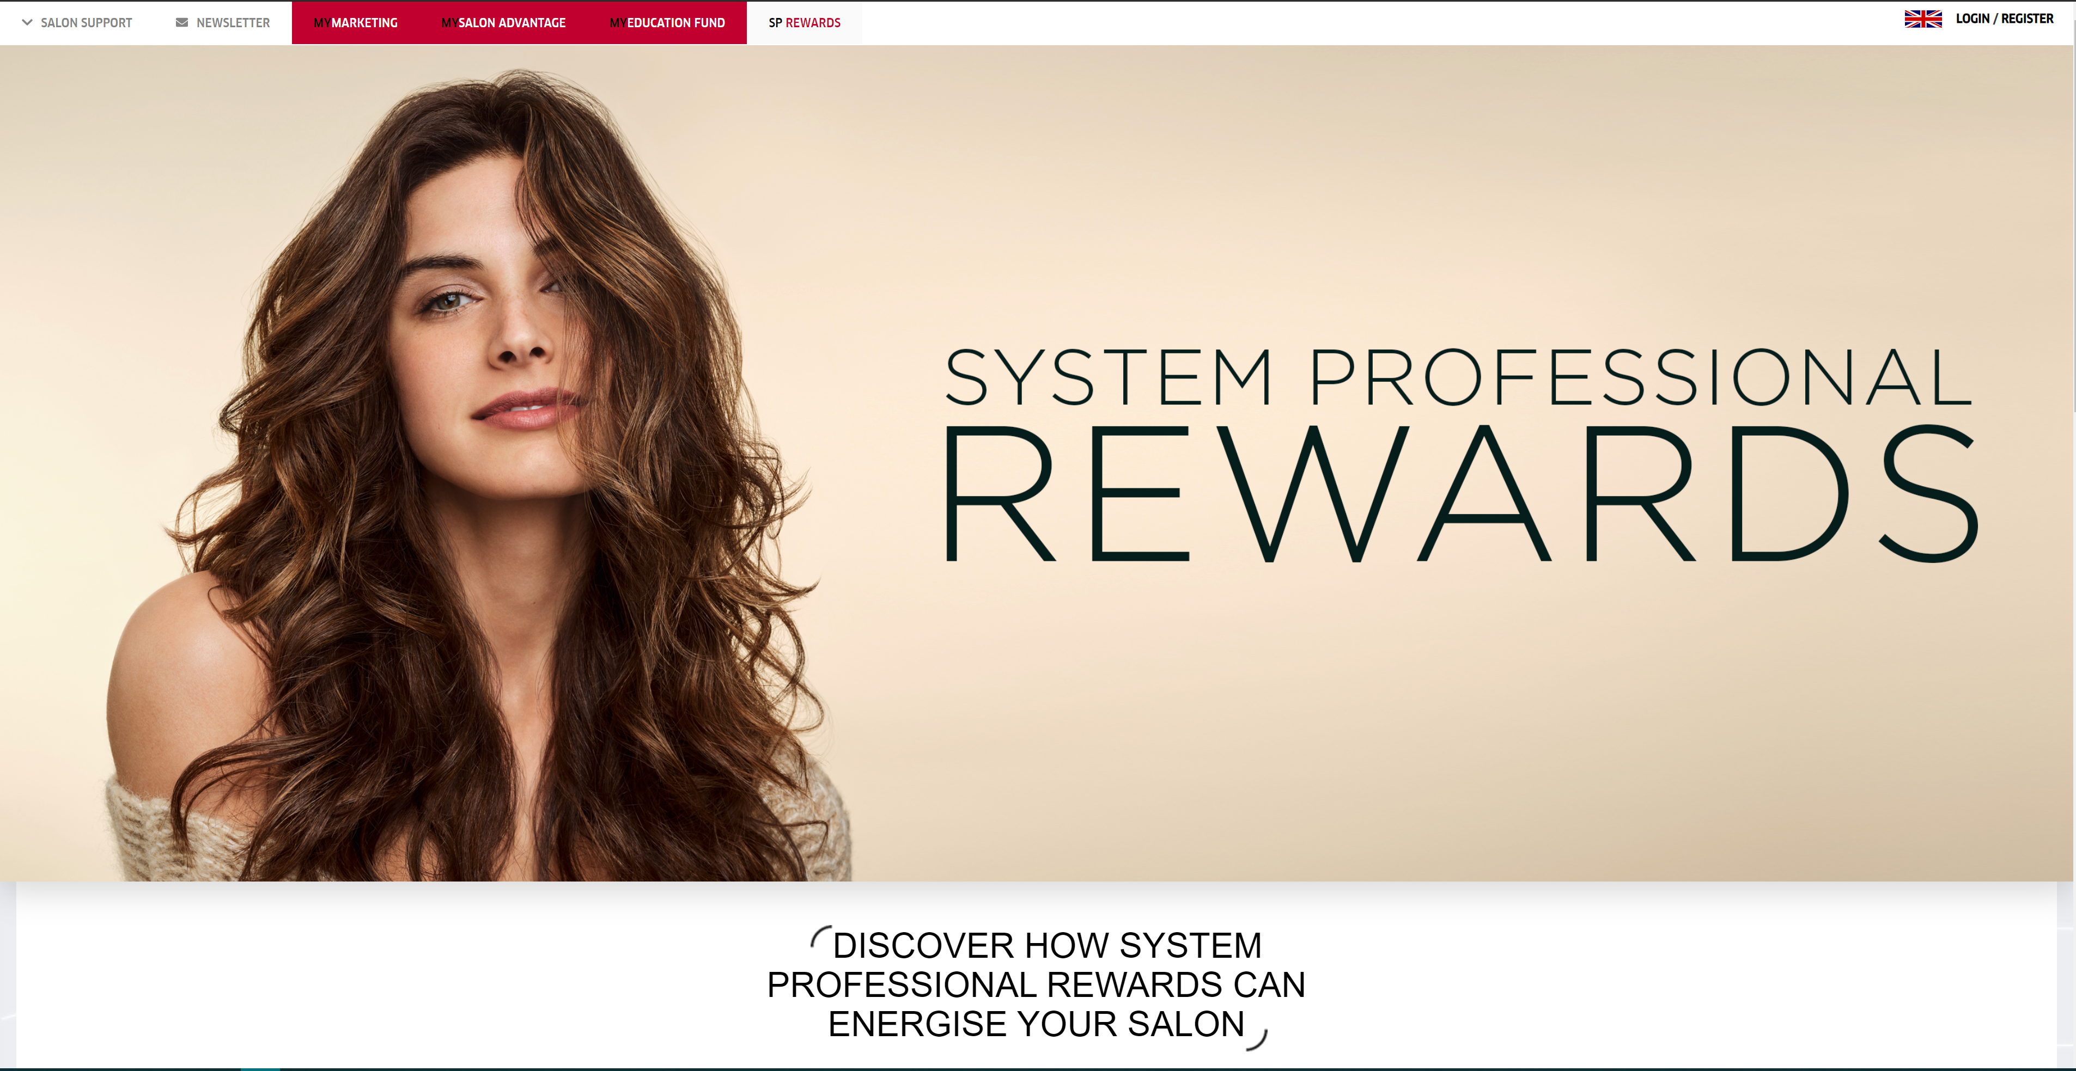
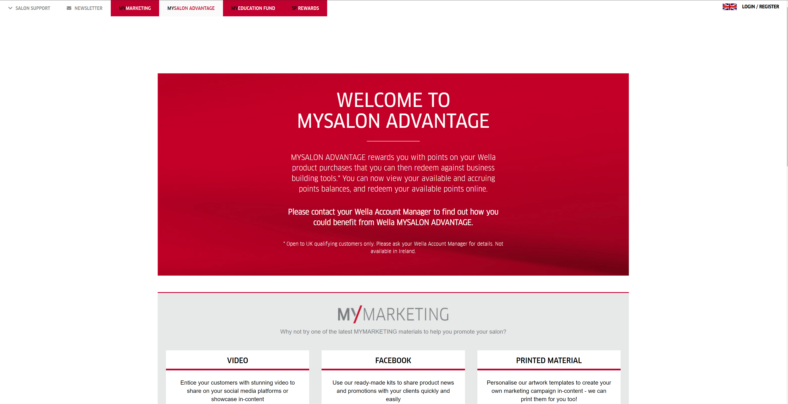
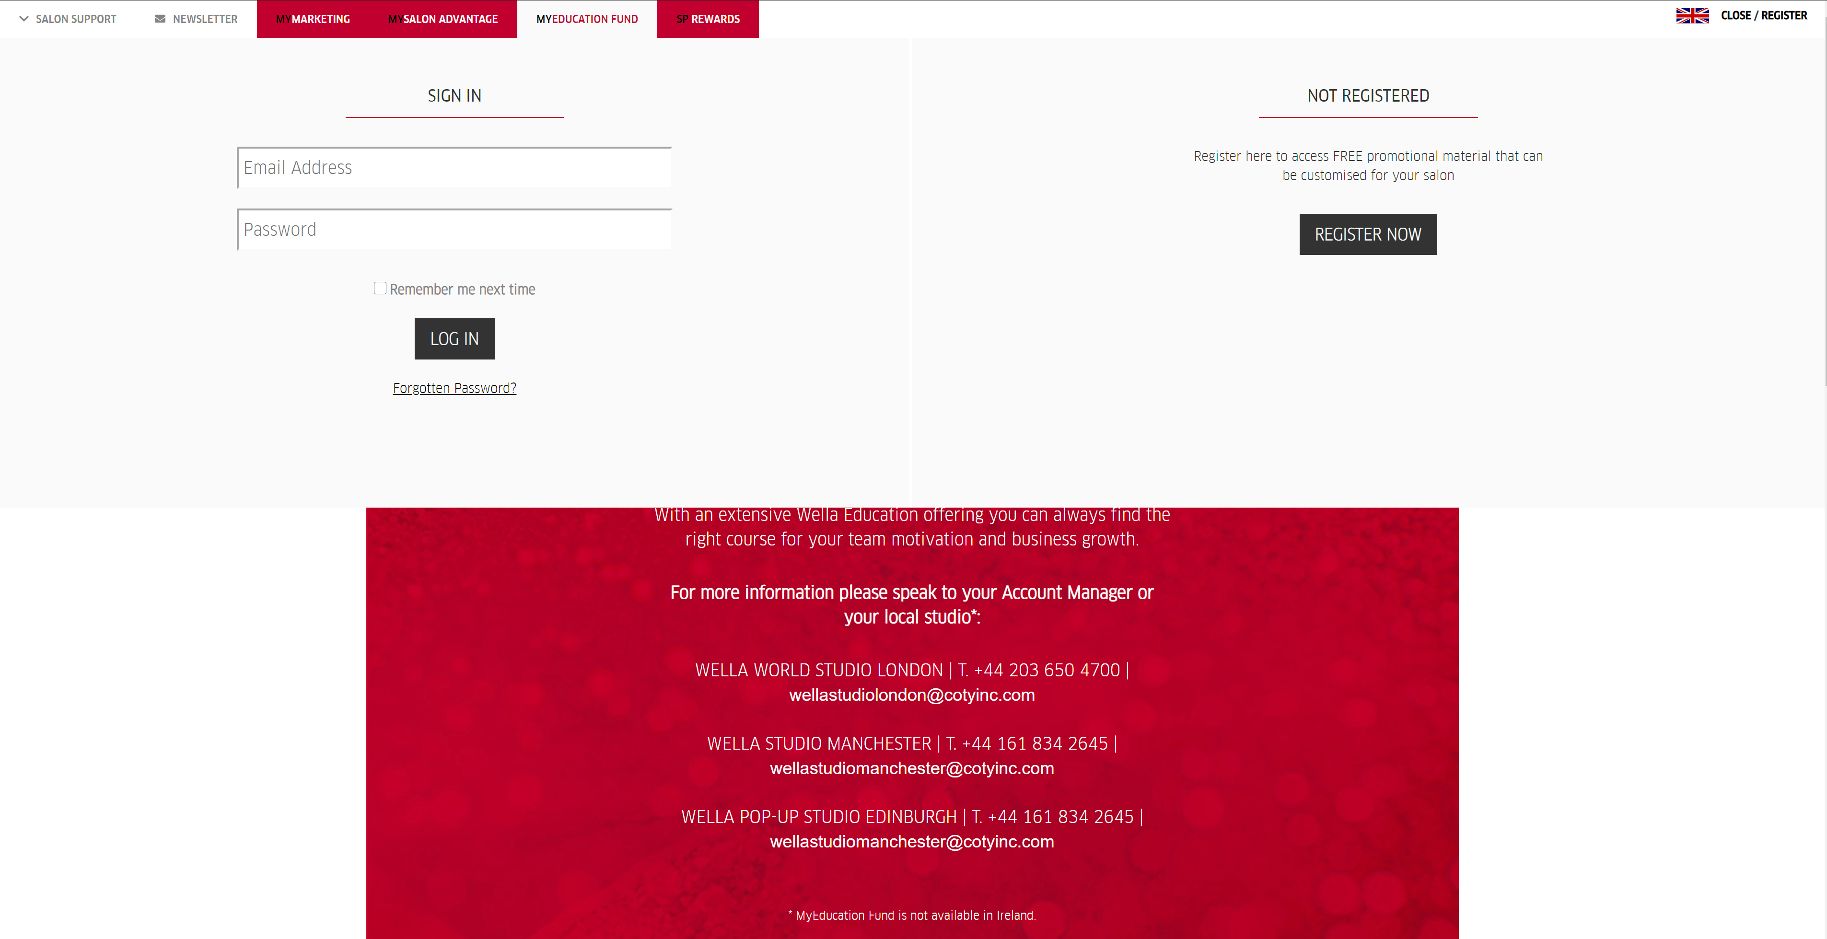
Apx.2 – Love Basingstoke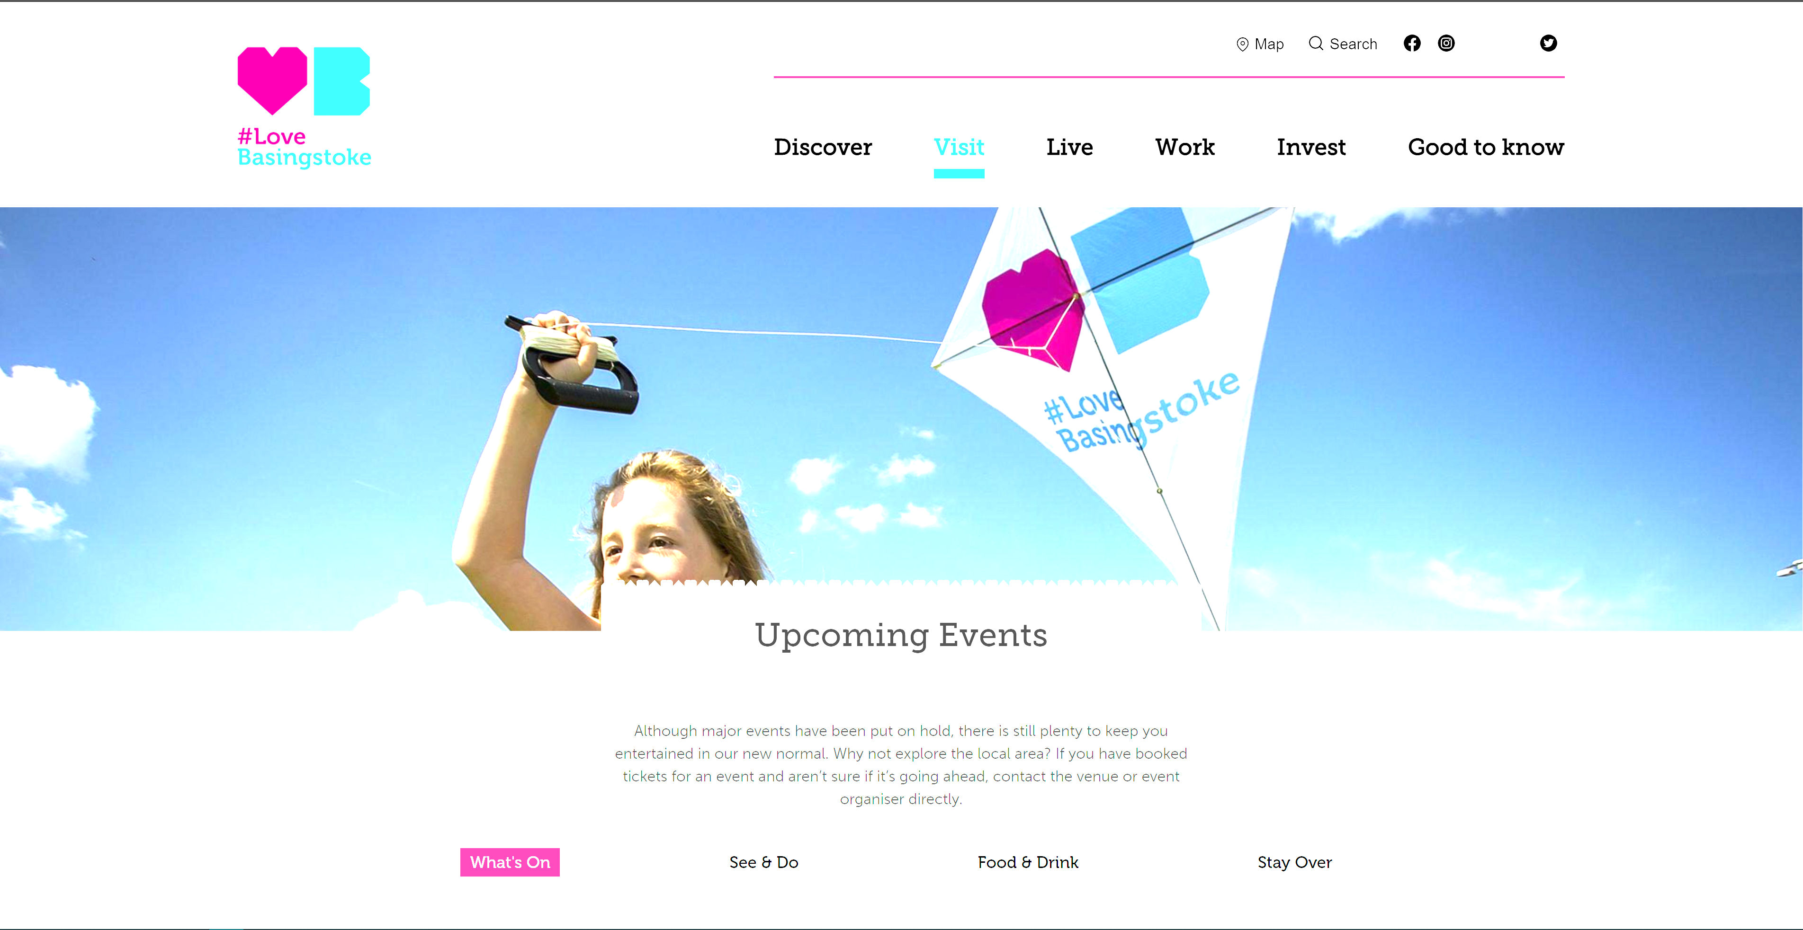

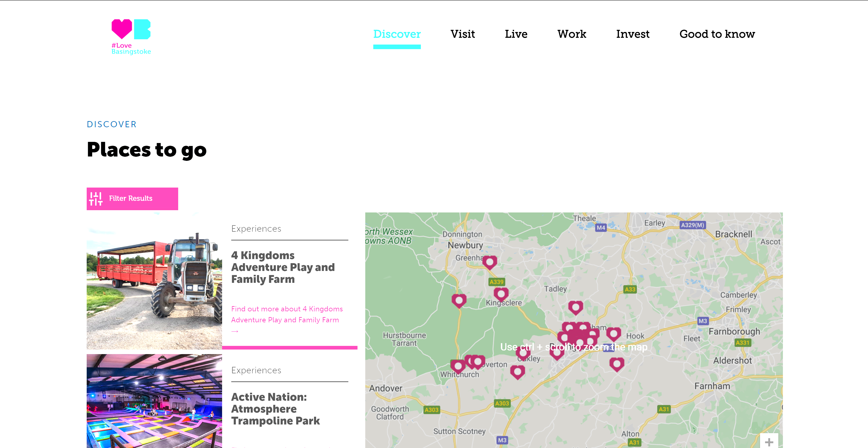
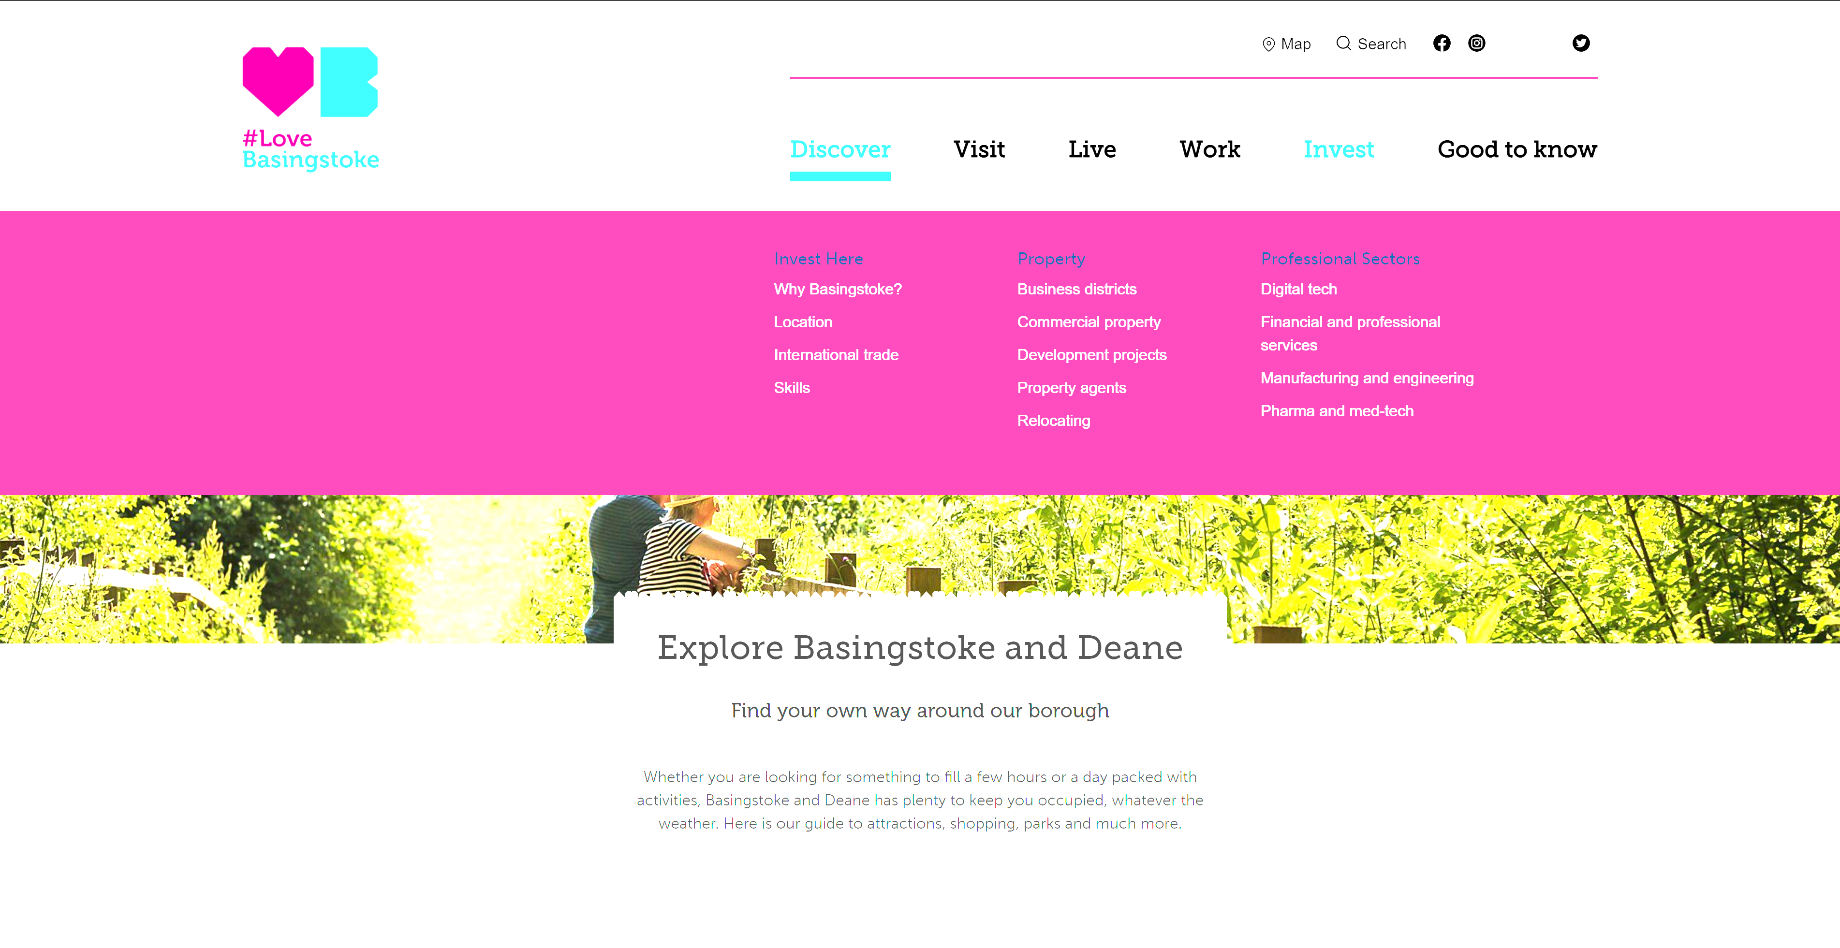

Apx.3 – Donater Refresh
https://donater.co.uk
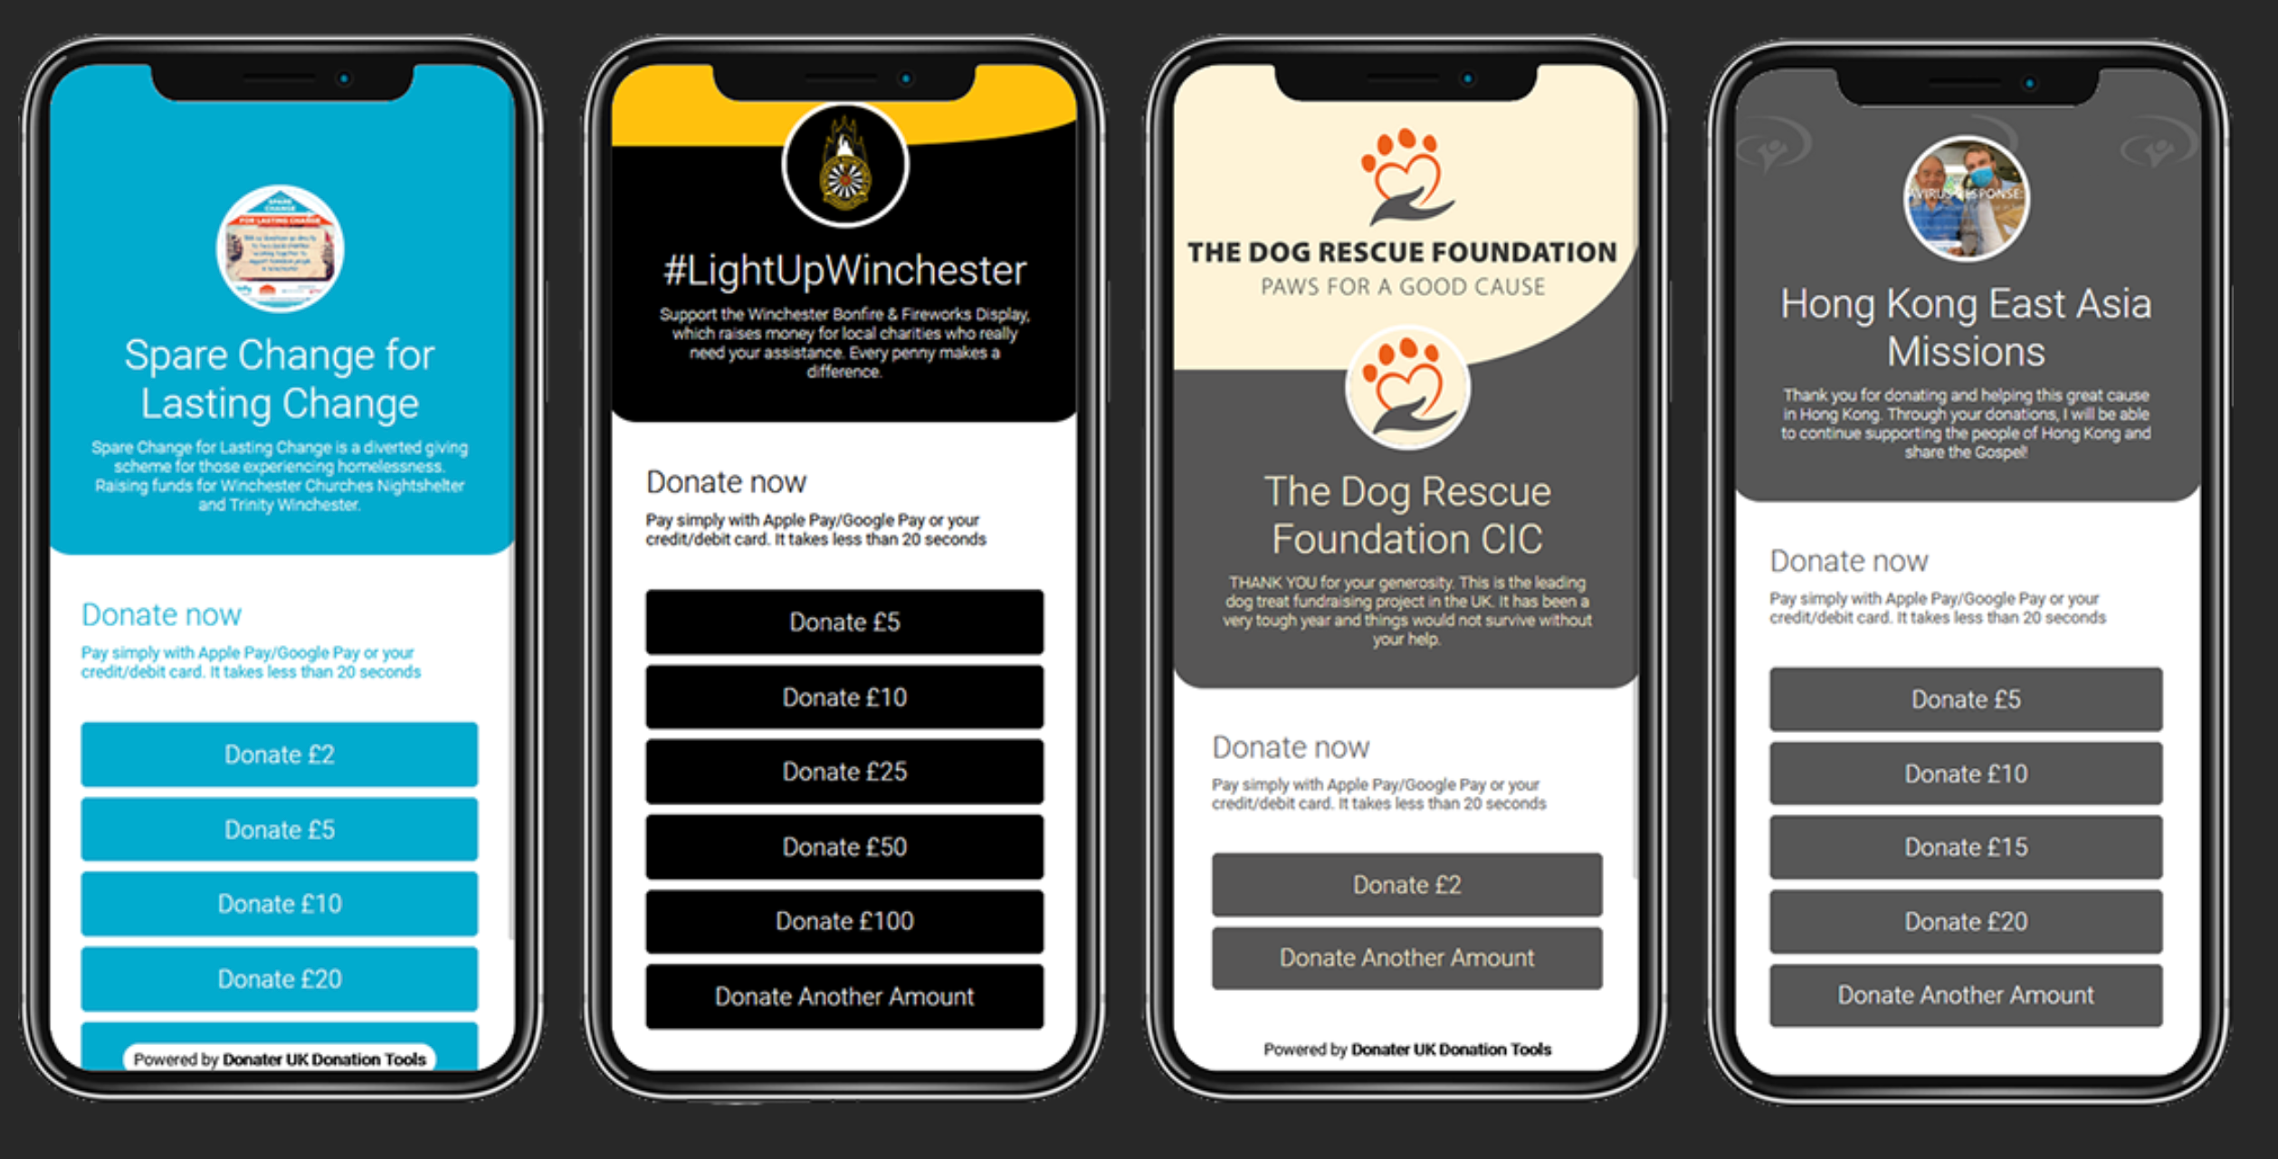

Apx.4 – Interaction Network Tool
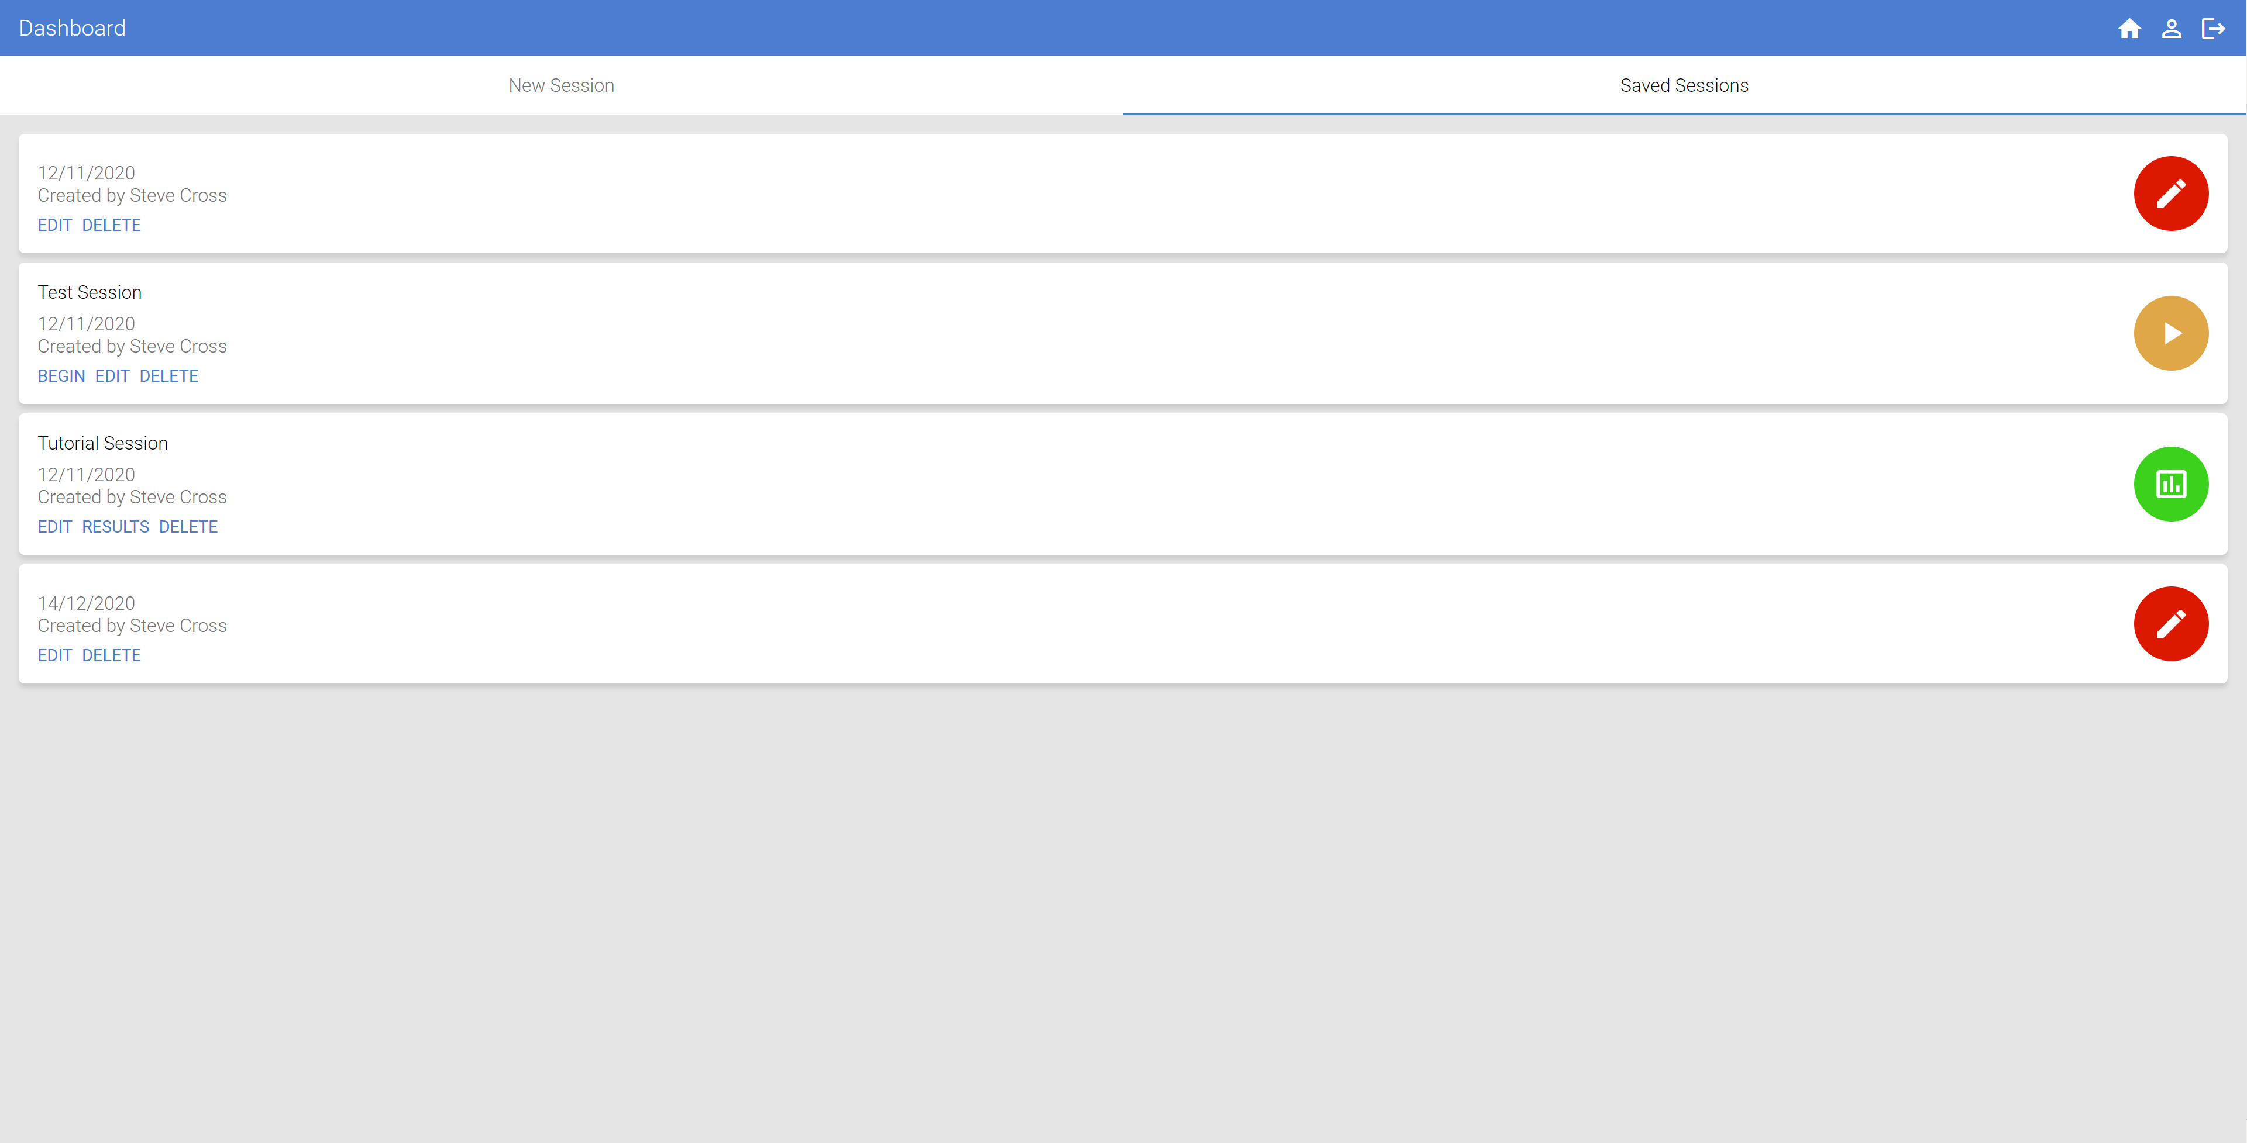
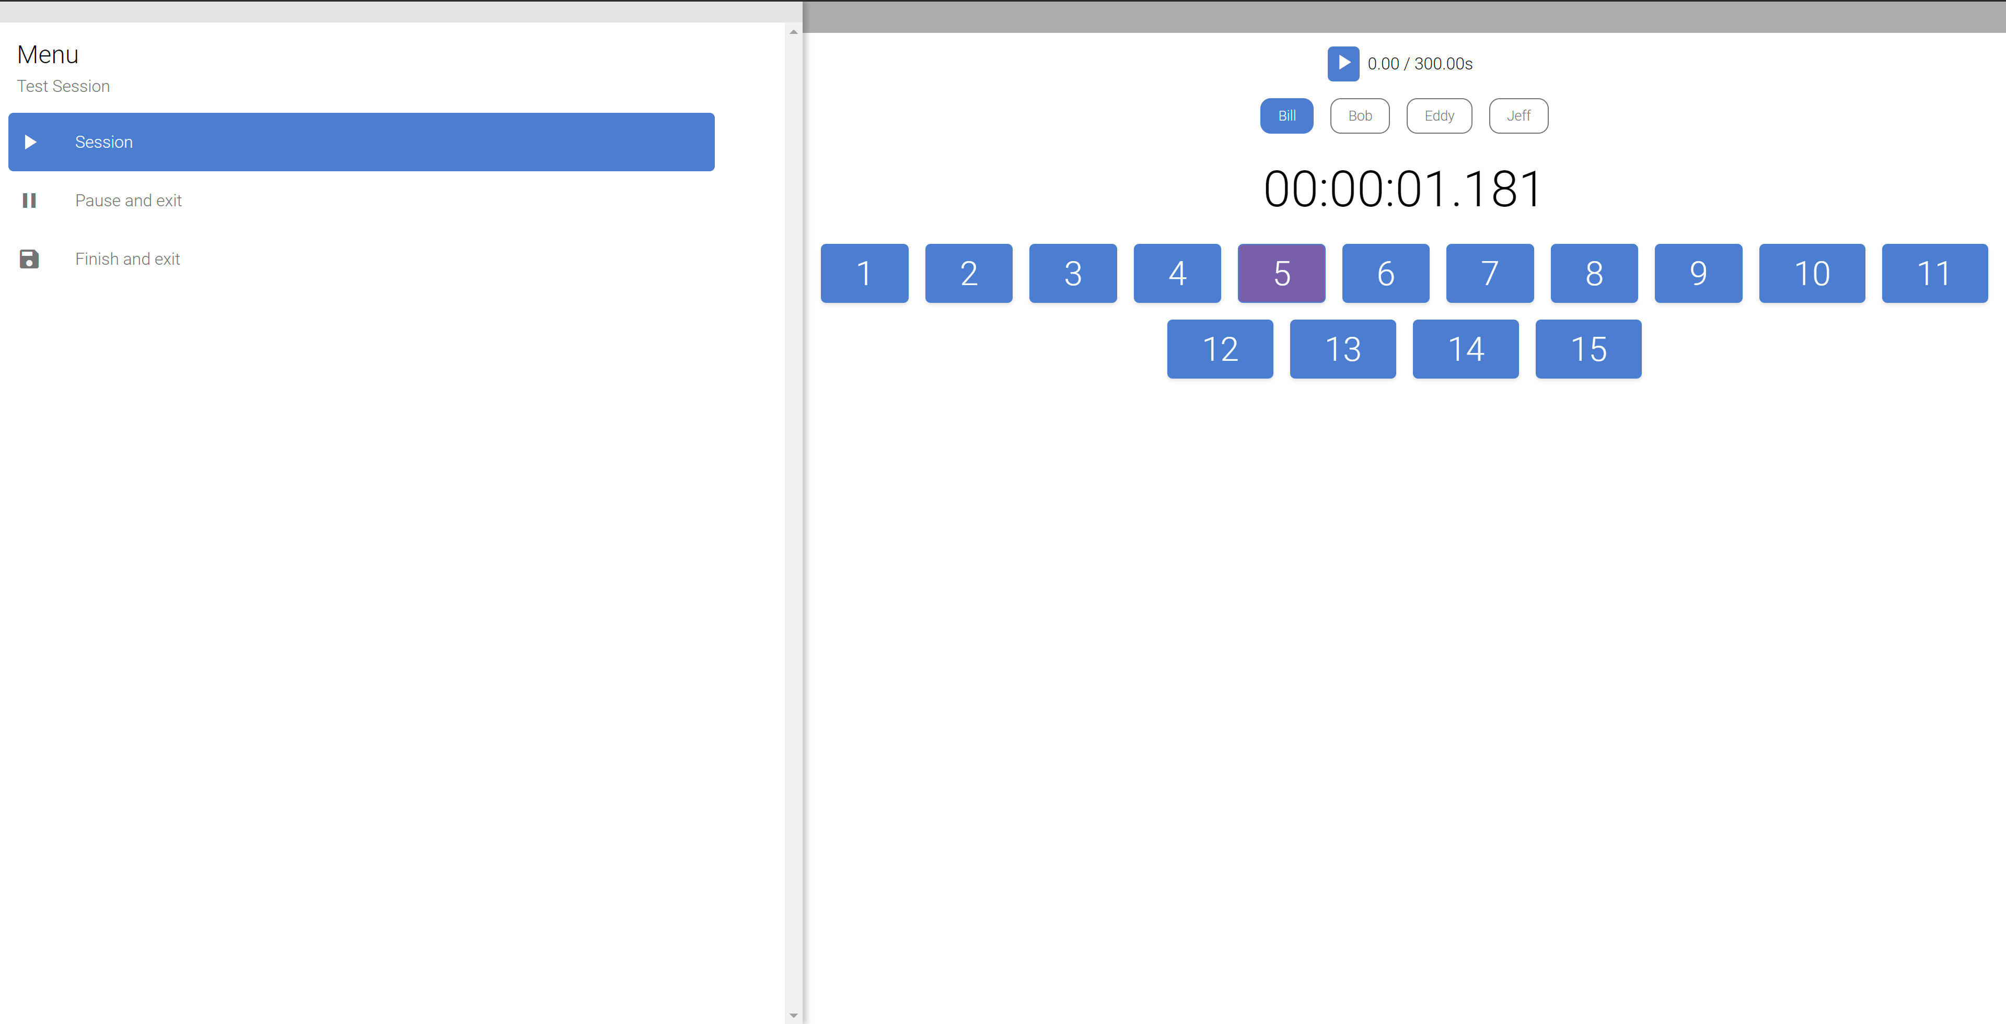

Apx.5 – Aura Gas Cover Calculator
https://auragas.co.uk/boiler-service-contracts/
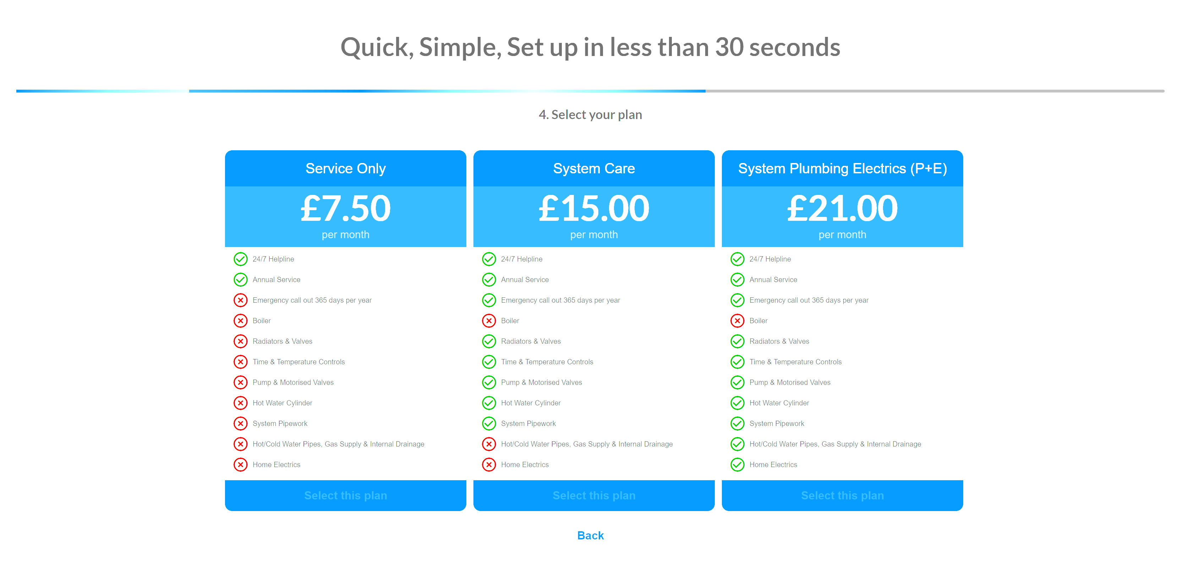
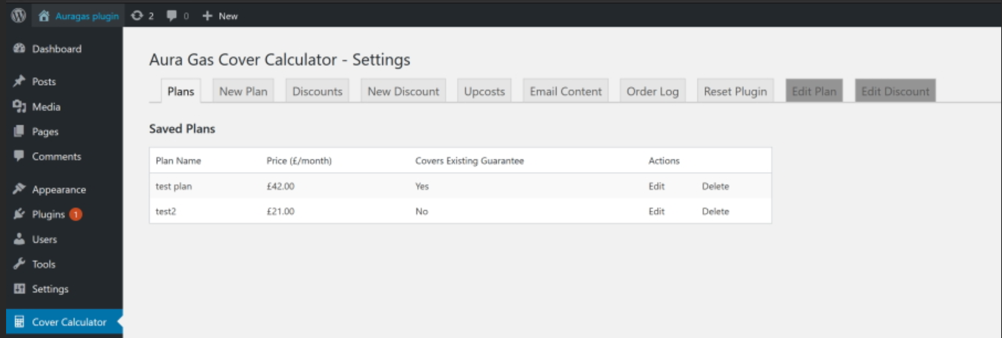

Apx.6 – Aura Gas App
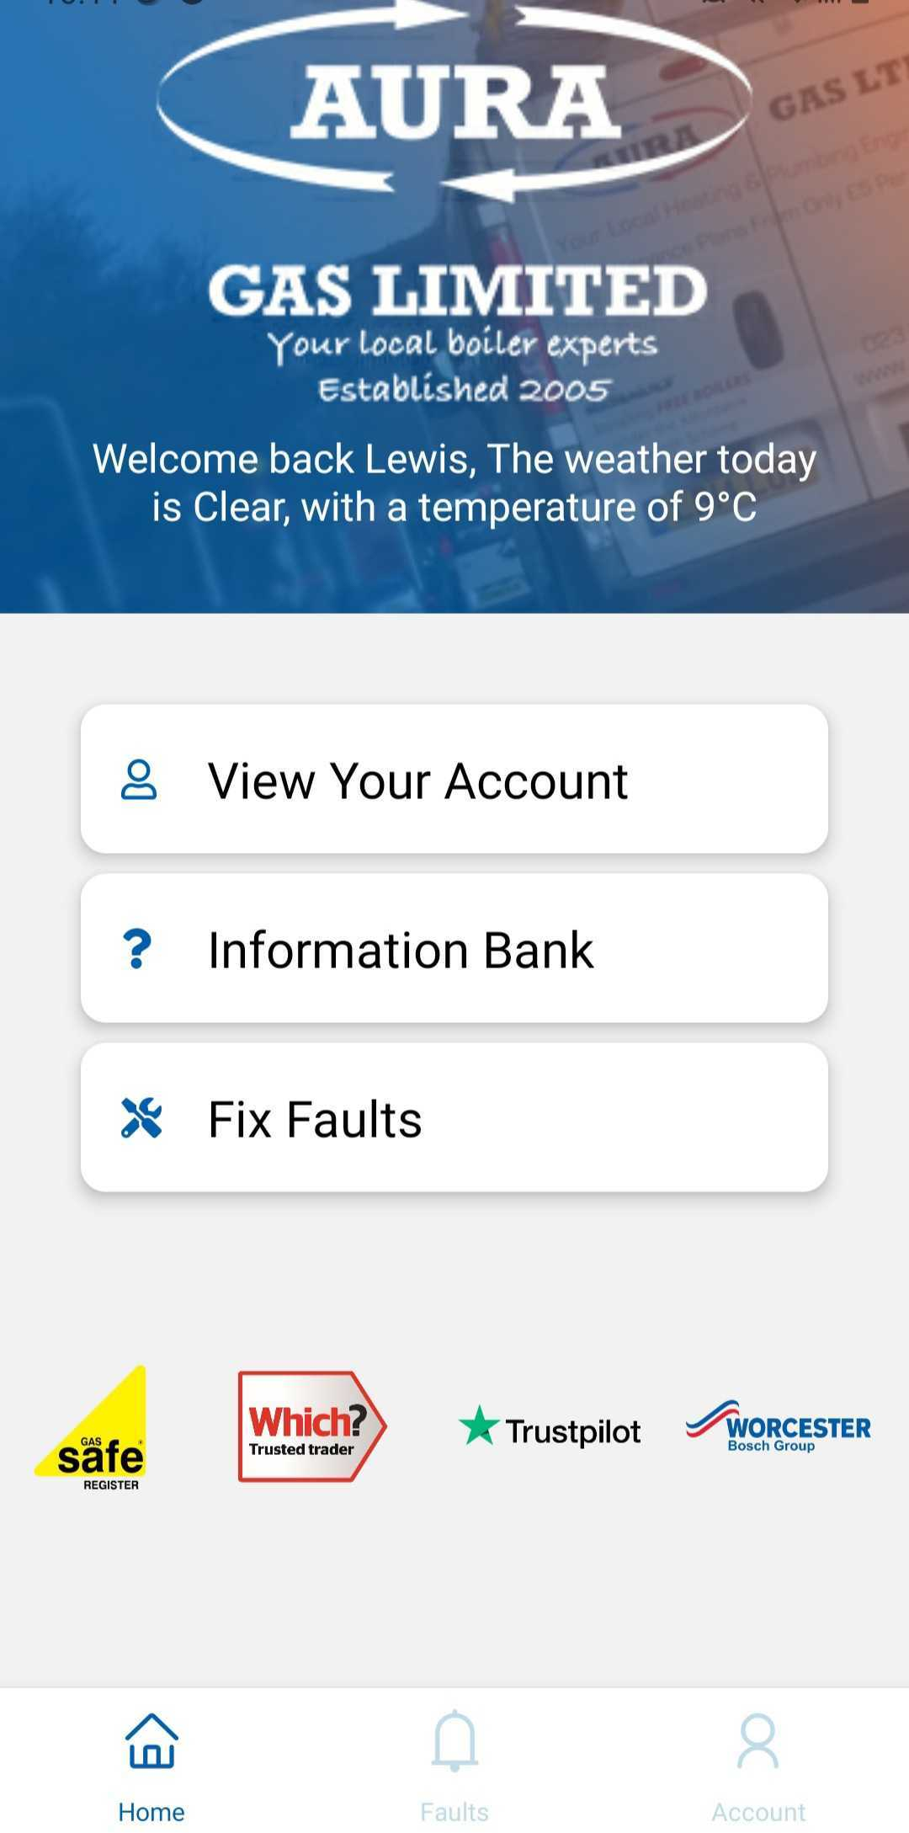

Apx.7 – Chloe Penn Illustrations
https://chloepenn.co.uk

Apx.8 – The Volunteering Research Hub
https://volunteeringresearchhub.co.uk
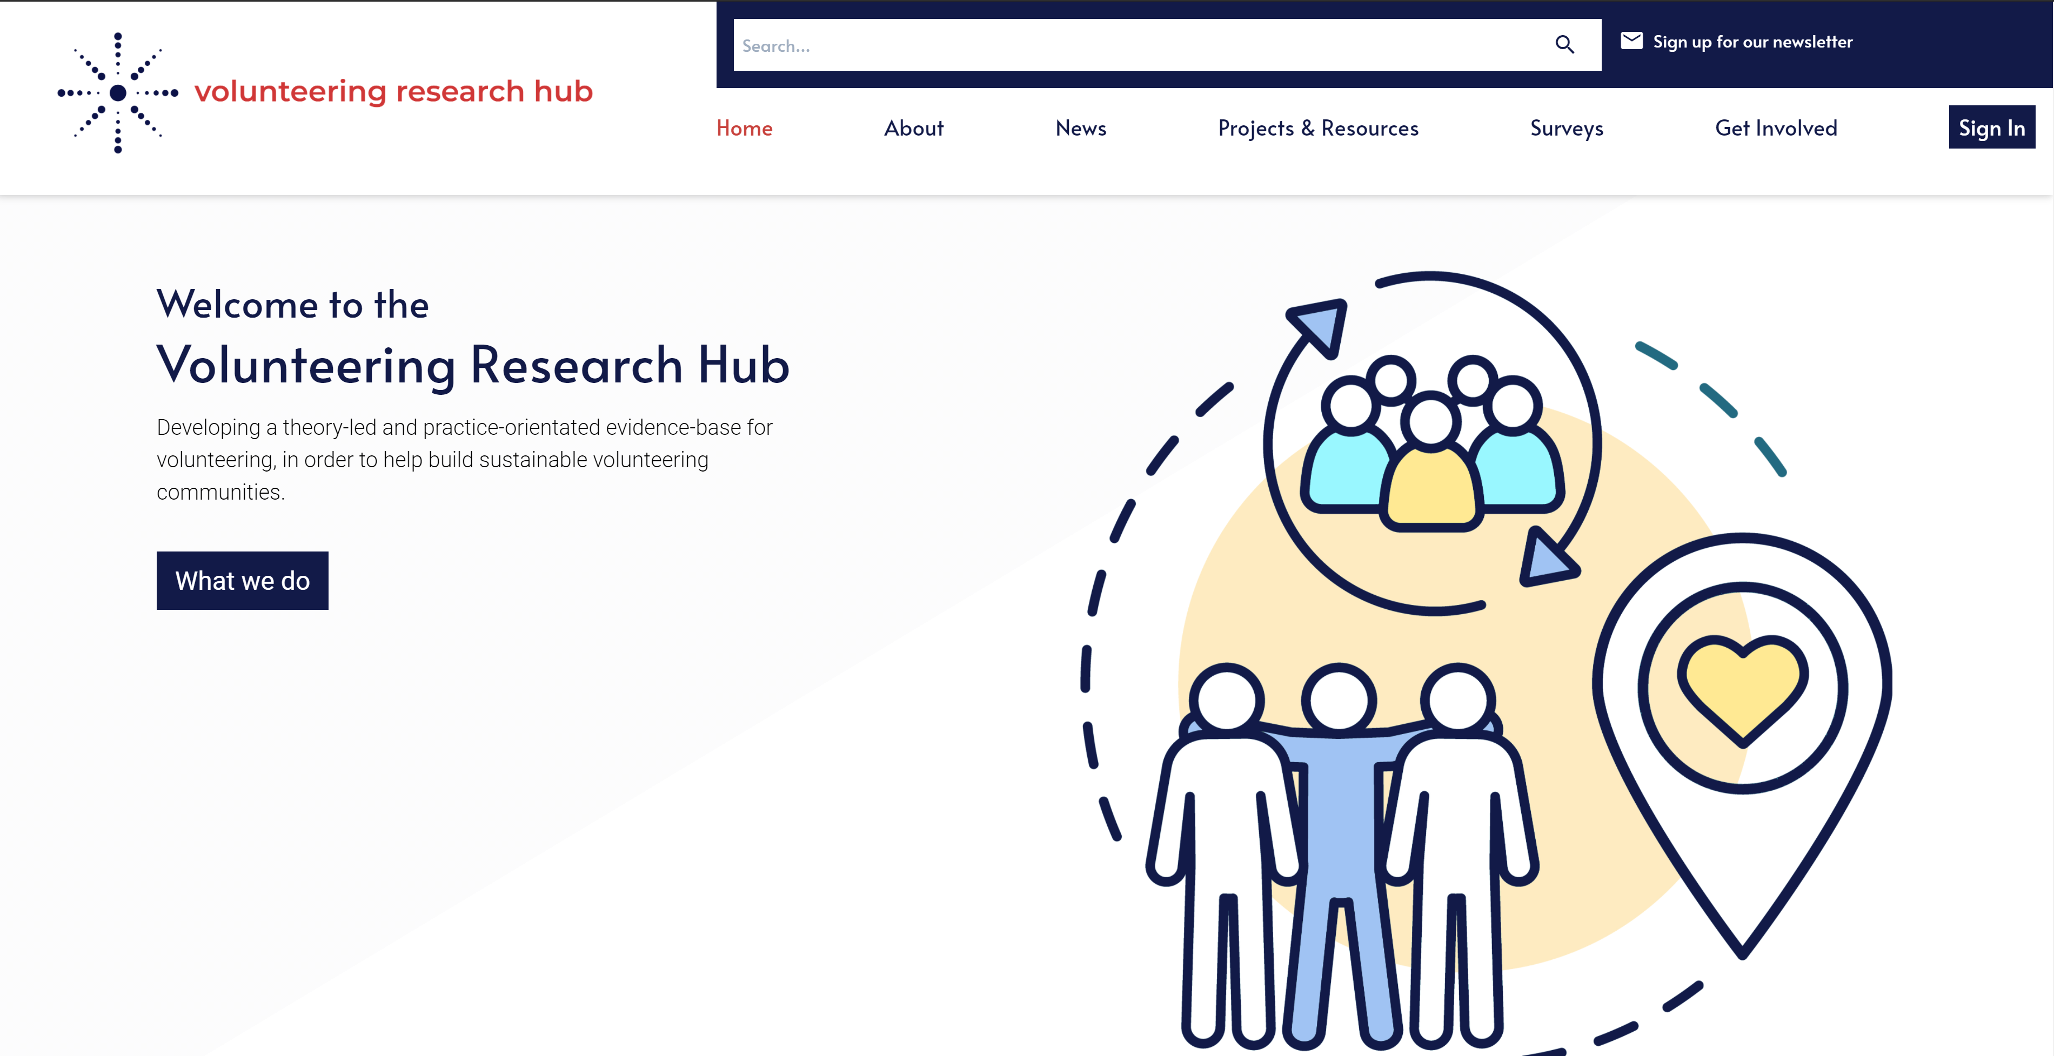

Apx.9 – Chloe Penn Illustrations Gantt chart
